Zombies and network models
Lesson context: We all love zombies. Or do we? This unit combines an exploration of network diagrams with the spread of a fictional zombie virus. In this lesson, students explore the use of network diagrams to represent connections, then apply a network-based COVID transmission simulation to hypothesise how a virus might spread through a small population. Students apply the model to predict the progressive infection of characters in Pride and prejudice, or a novel of their choosing.
Target year level/s: 9 and 10
Curriculum alignment
Mathematics
Design and conduct repeated chance experiments and simulations using digital tools to model conditional probability and interpret results (AC9M10P02)
Science
Select and construct appropriate representations, including tables, graphs, descriptive statistics, models and mathematical relationships, to organise and process data and information (AC9S10I04)
Design and Technologies
Analyse the impact of innovation, enterprise and emerging technologies on designed solutions for global preferred futures (AC9TDE10K02)
Learning hook
Infectious disease is a familiar topic for our students, both in their daily lives and entertainment media.
Introduce the topic by asking students what they know about zombie outbreaks in television shows or films. What is the pathogen? Who is susceptible to it? How does it spread?
Girls in focus
Girls may not associate popular culture with STEM pursuits. Beginning a unit by tapping into students’ areas of expertise – such as their knowledge of current television shows or films – affirms the cultural capital they bring to the topic and can build their confidence to engage with STEM.
Explain that epidemiologists study spread of disease using epidemiological models. Often, the development of these models represents a collaboration between scientists, mathematicians and systems engineers. Governments make decisions about whether to implement public safety measures based on these models and predicted outcomes of different interventions.
Have students explore HHMI’s SIR model of disease transmission. Work through the tutorial together, then give students the opportunity to investigate changing the parameters of the model.

As a class, discuss the strengths and limitations of the simple grid SIR model for modelling transmission of a disease. For example, draw student attention to the number of people who can be close contacts, and ask if this represents all possible infection scenarios. Through discussion, explore how else we could model close contacts.
Learning input
A newer model for simulating disease transmission involves using network models to represent the population.
Students will have come across network representations in different aspects of their STEM learning, such as computer networks and food webs.
Network models are a way of representing connections or relationships between objects. Each object is represented as a node and connections between objects are represented as links. Watch this video to understand social network analysis.
Before they can explore network models and spread of disease, students need to be familiar with this type of representation. In particular, they need to understand nodes and edges. This article provides a great starting point for understanding social network models and considering how a systems engineer might use network representations compared to an epidemiologist.
Students can create their own social network representations using FigJam, a free Figma template.
Have students watch an episode of an ensemble drama or comedy – one where there is a group of major and minor characters who all interact in different ways. As a class, make a list of all the main characters, then draw lines between them to show which characters interacted across the episode. Where characters had multiple or sustained interactions, show this by drawing a thicker line to link them.
As a class, discuss whether the social network map for every episode would look the same. If not, explore what might change.
Explain to students that we can also use network models to explore spread of disease through a population. Have them explore this simulator from LabXchange, which models COVID transmission using networks.
Tell students to set the simulation type to ‘static’. This will give them a series of transmission periods, and they will be able to see the progression of disease across those periods. Give students some time to investigate changing the simulator parameters and practise interpreting the transmission network diagrams that result.
Discuss what is meant by the different link colours, and the difference between asymptomatic and quarantined individuals. Explore the assumptions made in this model.
Girls in focus
Engineering lends itself to connecting many different fields with STEM. A career in engineering can be similarly diverse. Listen to this talk from Professor Ellen Kuhl, a mechanical engineer who has applied her expertise to developing computational models to predict the response of living structures to disease.

Learning construction
Back to pop culture! Students can explore modelling disease through introducing a zombie pathogen to a classic ensemble novel. Have students create a network representation to show the interactions between characters in one chapter of Pride and prejudice, or use one of these maps as your starting point.
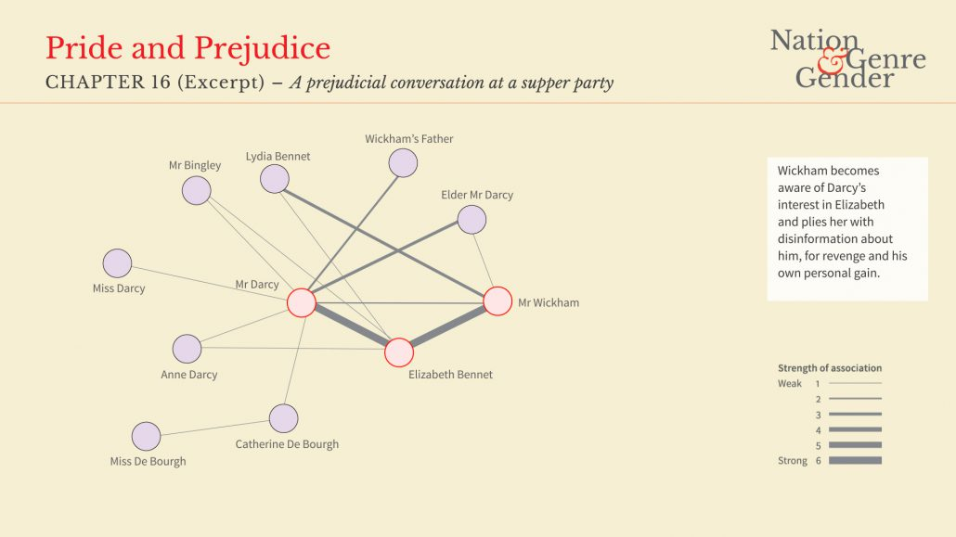
Image Source: Nation, Genre, Gender SNA Project by Gerardine Meaney, Derek Greene, Karen Wade, Maria Mulvany, Siobhan Grayson, Jennie Rothwell is licensed under a CC BY-NC
Alternatively, students could select a chapter from another novel – note that the chapter should feature all the characters coming together in different groups and should include an ensemble of at least eight characters.
Now, students imagine one character is infected with a virus (let’s call it Zombixitus).
First, students will need to describe the disease and determine the probability of an individual infecting others.
They will then select a character randomly to be the first one infected with Zombixitus (different individuals or groups may select different characters).
Students can then use the LabXchange network simulation model to see how the virus might move between characters. Who would be infected and in what order?
Note that in this model individuals are quarantined and recover.
Challenge students to create a series of transmission network diagrams to show what might happen if some individuals were not quarantined but stayed active in the community.
Students can then write a short alternative chapter to match the transmission network diagrams and describe the spread of disease through the ensemble.
Girls in focus
Girls may not appreciate that the skills they develop in STEM are readily transferable to other learning areas. By connecting mathematical representations to fiction, students can appreciate the value of STEM as a journey, as well as a destination. In addition, by tapping into girls’ talents in other, non-STEM fields, you can support them to bring the confidence they feel within those identities to their STEM pursuits.
Rubric
Criteria | Beginning | Achieved | Exceeded
Disease characterisation | Describes how the virus is spread and selects a probability of infection. | Describes how the virus is spread and links this to a reasonable probability of infection. | Describes how the virus is spread and links this to a justifiable probability of infection and likelihood of social distancing measures.
Network representations | Creates a series of network diagrams showing progressive infection of the ensemble. | Creates a series of network diagrams that correspond with events in the chapter to show a likely progression of infection through the ensemble. | Creates a series of network diagrams that correspond with events in the chapter and the disease characterisation (for example, likelihood of recovery) to show a likely progression of infection through the ensemble.
Alternative chapter | Writes an alternative chapter in which characters are progressively infected. | Writes an alternative chapter that corresponds with the network diagrams to dramatise the progressive infection of the ensemble. | Writes an alternative chapter that corresponds with the network diagrams and disease characterisation to dramatise the progressive infection of the ensemble.

